Javascript Basics (es6):

* Var, let, const
* Arrow functions
* Spread and rest operators

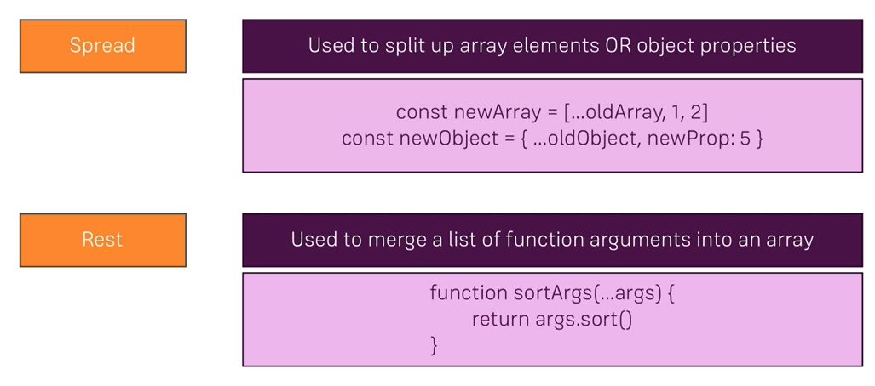

* DE structuring

React JS

* State-->Data attached to Component
* Any Compoenet that has a state, needs to be a class
* Prop--Way of Getting data

# Samir Understandings

* First we need to get “React Cli”
* The way of getting React Cli is by the following command
  + Npm install -g create-react-app
* The above command installs “create-react-app” REACT CLI globally
* We need to use the following command, to create a react application
  + Create-react-app “APPNAME”
* We will be getting the following folder structure

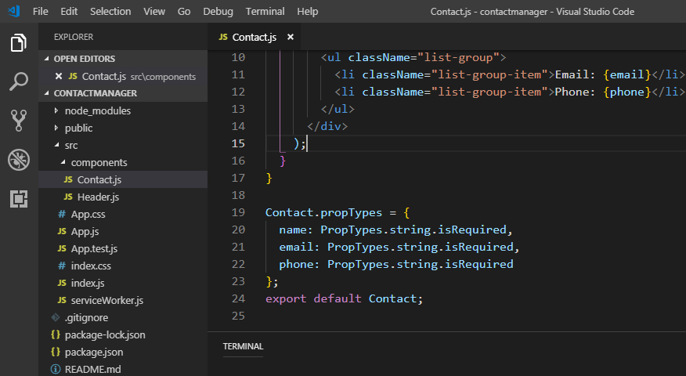

* Here “components” folder is created by me

# Explanation of the folder structure:

* Here App.Js is the “PARENT COMPONENT” of all the components that will be created
* What ever component we create, we need to call the TAG of Created Component in the JSX part of App.js file.
* For example, if, we create a component called “**Header**”, the same has to be called in the following way in JSX of App.js

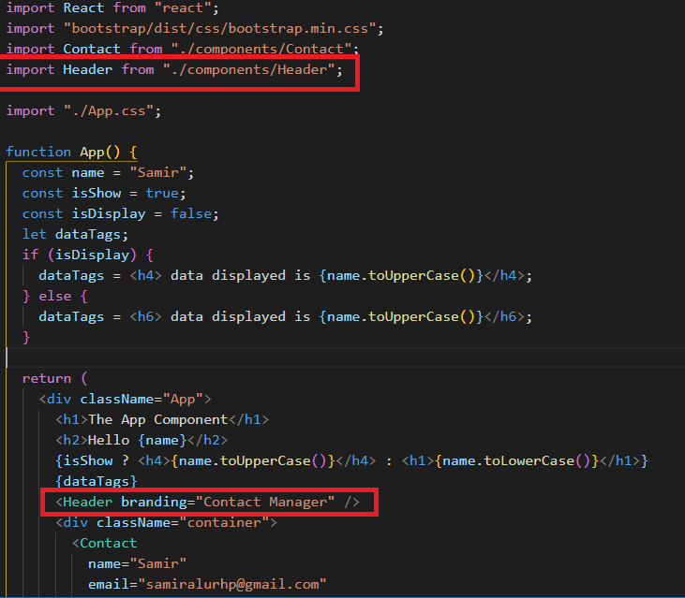

* App.js file has only “**return()**” function only and will NOT have “**render()**” function

# General Structure of a Class Based React Component:

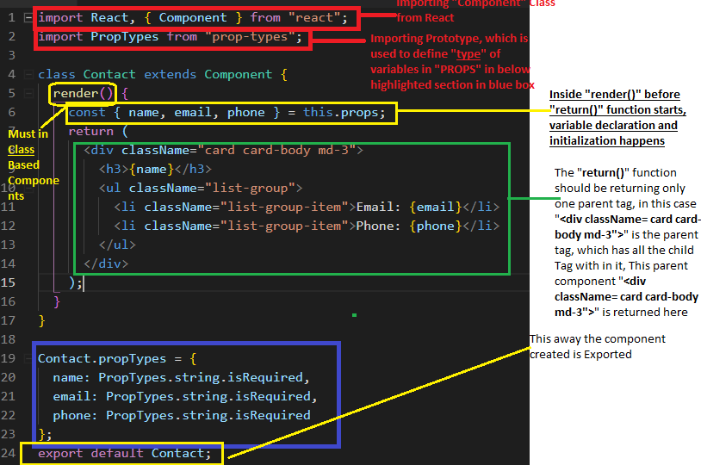

* The Above Class Based Component is IMPORTED and USED in App.js or to that matter in any component in the following way

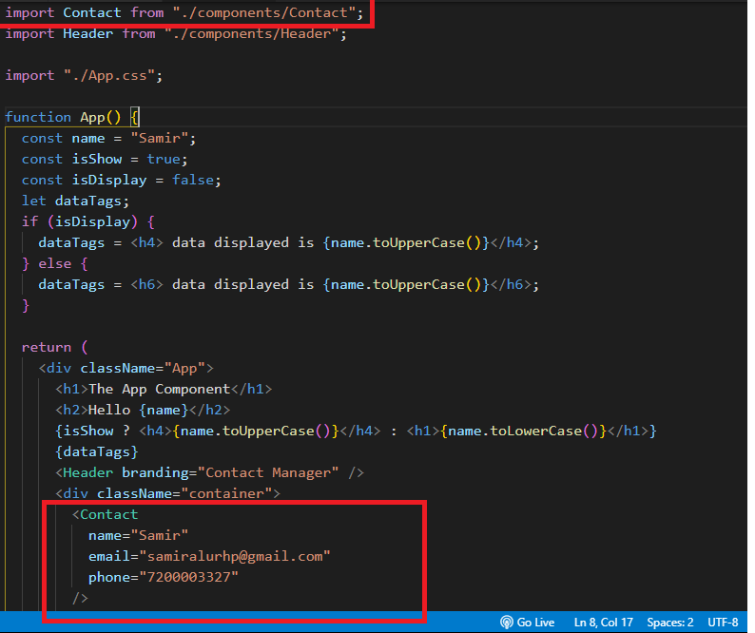

# General Structure of a Functional Based React Component:

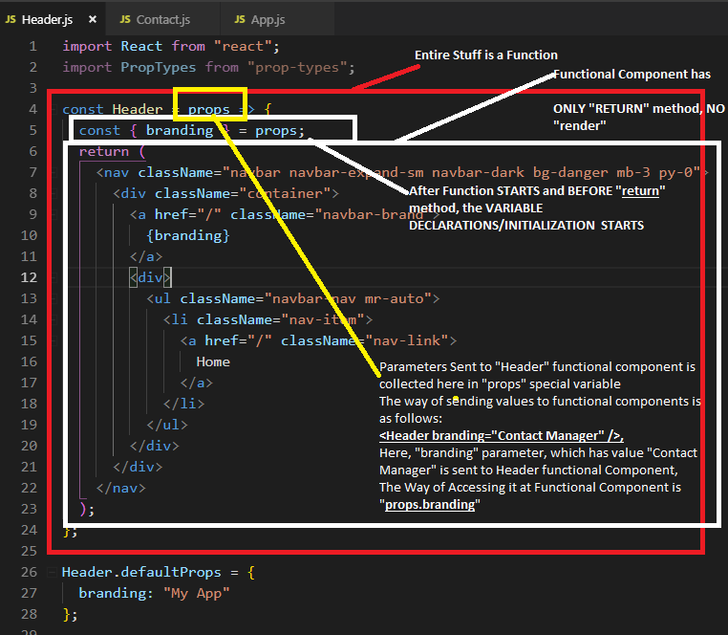

# Way of accessing Passed parameter values in class based components

## In App.js

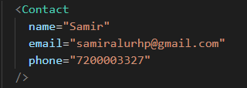

## In Contact.js, which is a class based component:

* Way of accessing **this.props.<parameterName>**

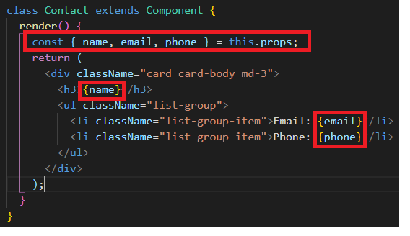

# Way of installing and using bootstrap in React:

* As a first Step, we have to install bootstrap using the following command
  + npm install bootstrap
* Then call the bootstrap css in the App.js in the following way



* After calling, we can use the bootstrap class as usual, any where across the app.

Creating a state

# What is a State?

* + Any Data attached to the component is called state, so basically, This Data attached to the component would change, based on the “EVENTS, that are defined on HTML Elements in JSX.

# So Where are State Defined?

* Generally, State is present ONLY in **Class based Component**
* STATE is PRESENT or DEFINED Inside “CONSTRUCTOR” of Class based Component, please view the below screen shot

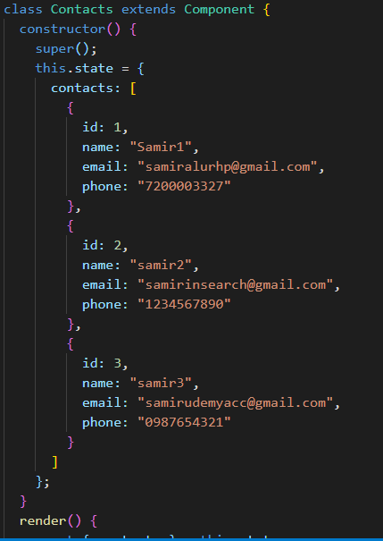

# How it is Used?

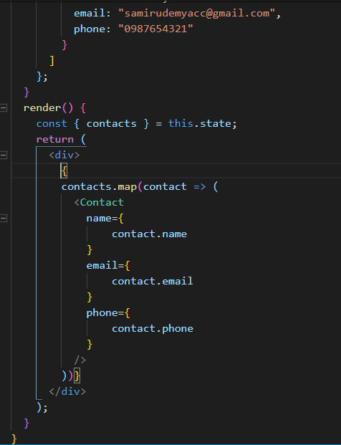

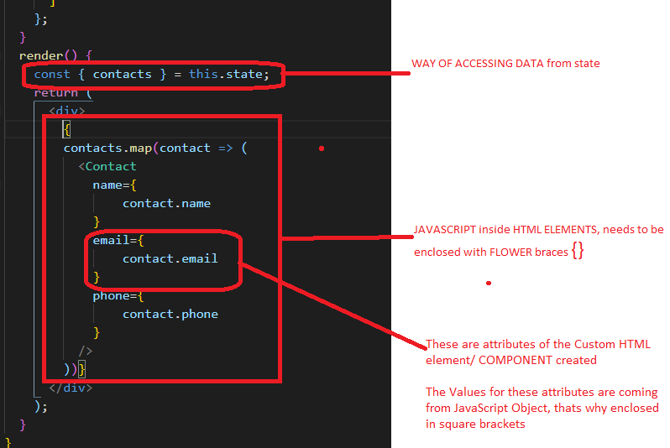

Events Tagged or Binding

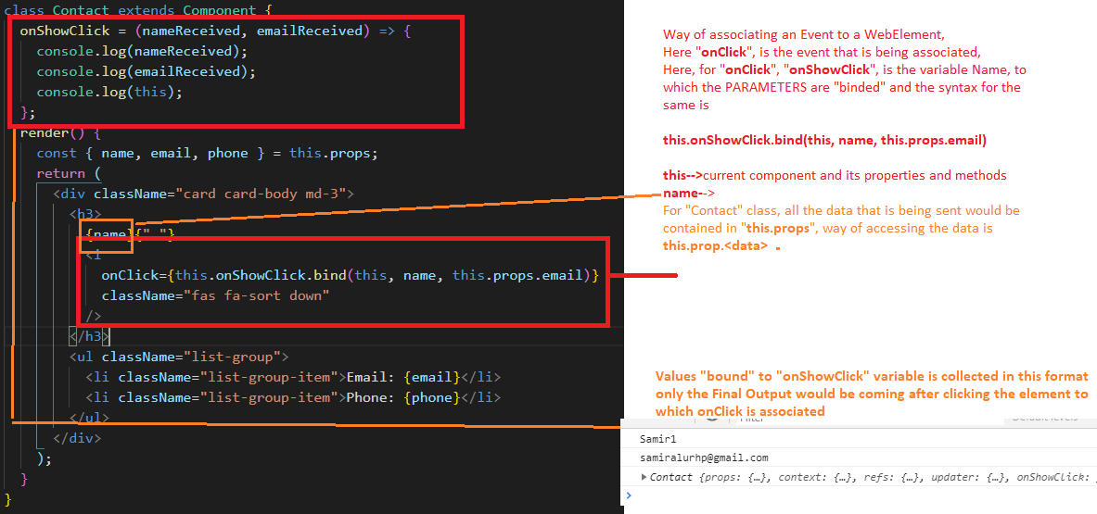

Functionality of Toggling when Clicked on WebElement

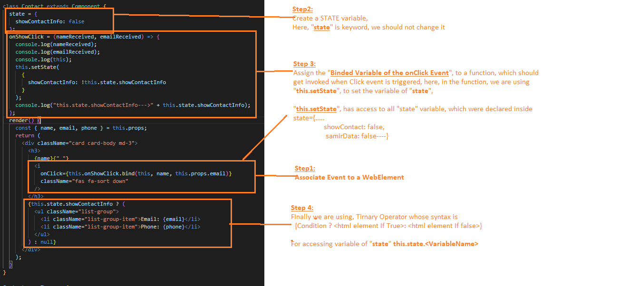

Setting up Communication between two React Components

* Here, we are deleting data

PROJECT LOCATION:

C:\Users\samir\contactmanager

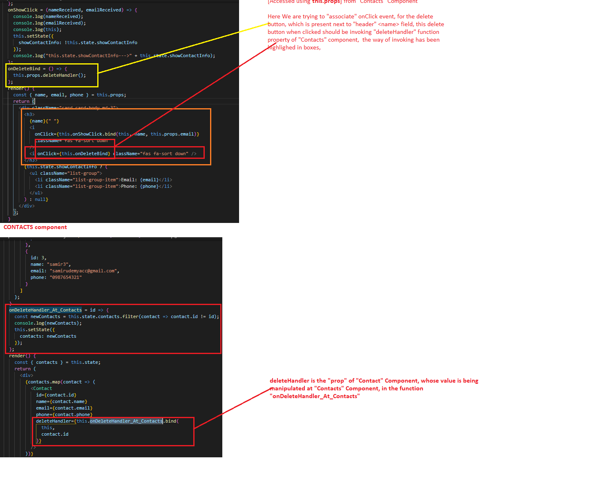

Context API

* A Context gives a “**Provider**”, which wraps the entire application inside <Provider></Provider> Tags, this Context has “STATE”, which is accessible to entire application, through “<Consumer> </Consumer>” tag.

## General Structure of Context Class:

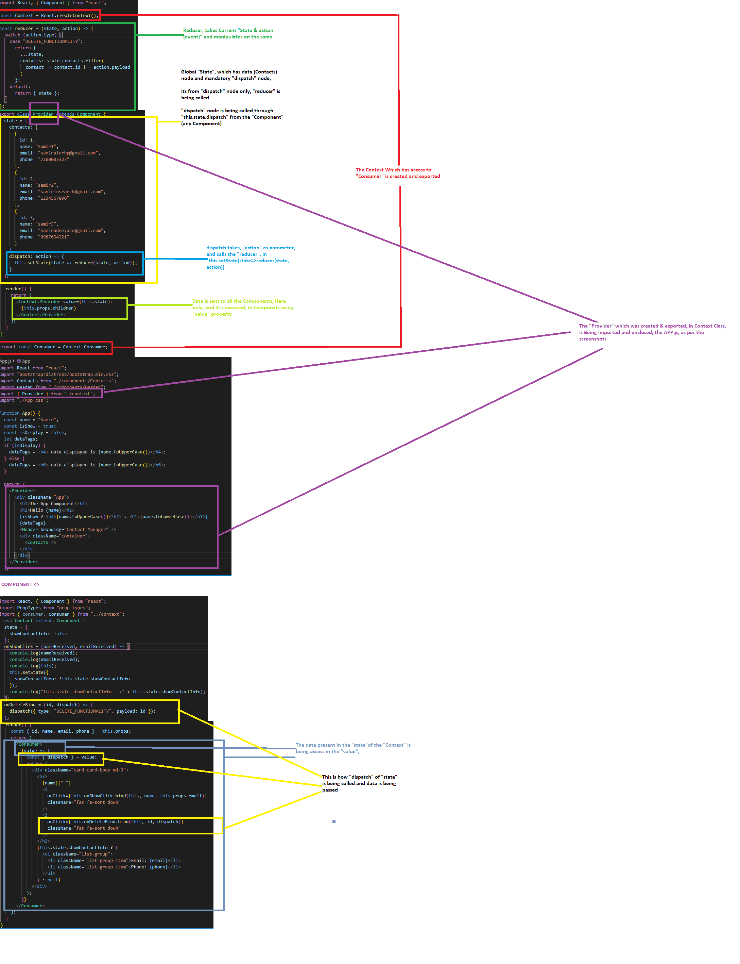

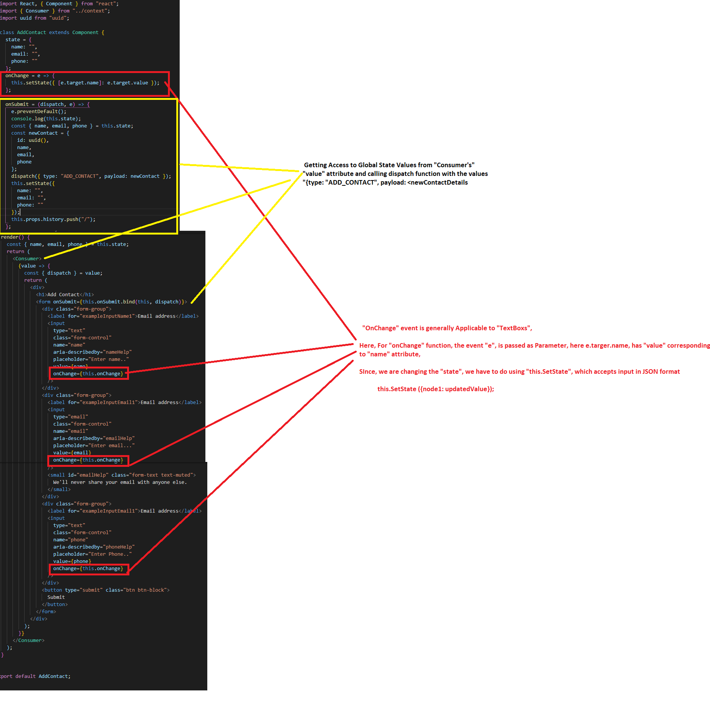

React Router:

Install following npm module:

npm I react-router-dom

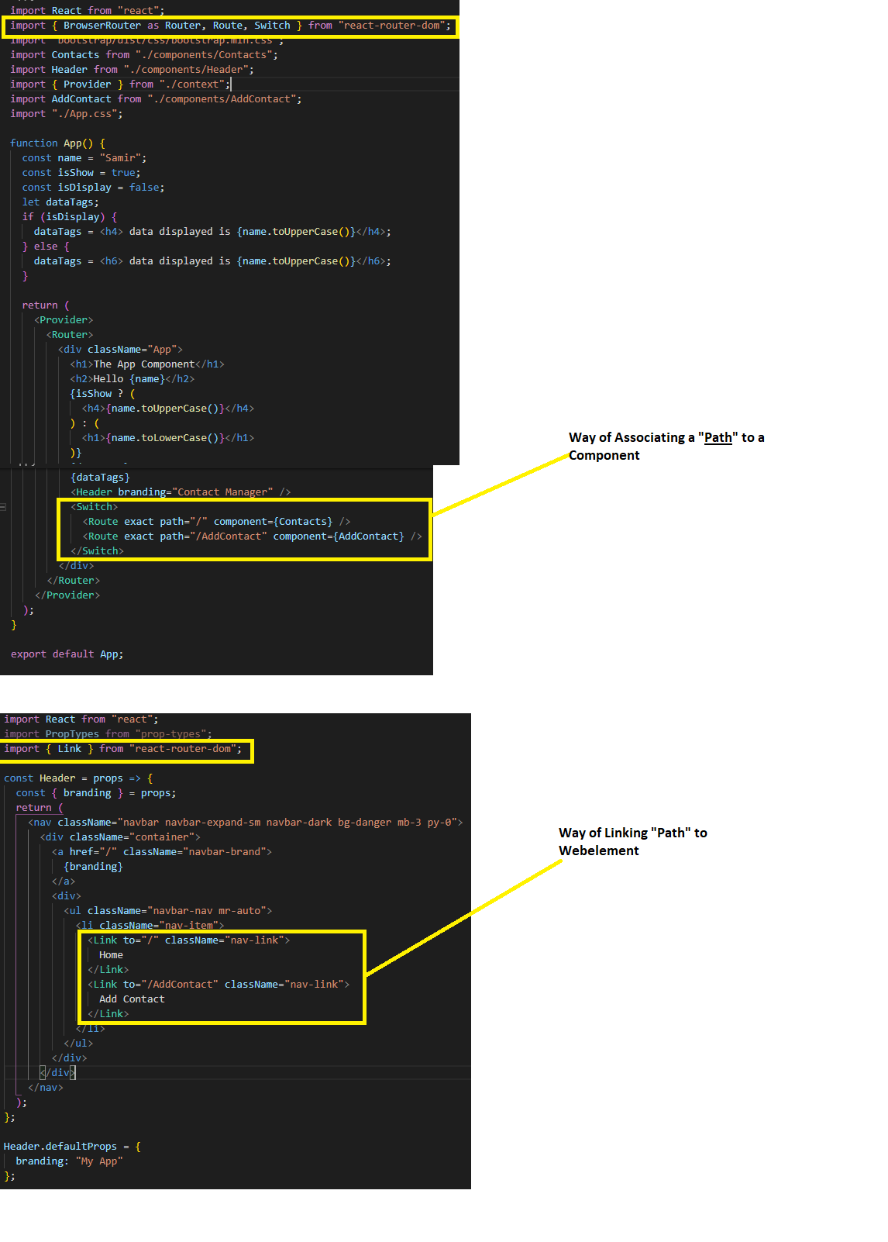

# React Life Cycle Methods:

* Life Cycle Methods are available only in Class based Components